**Homework 2 - Stoichiometry and Reactions**

**Description:**

In this assignment, you will have the opportunity to apply your nomenclature knowledge, practice stoichiometry calculations, balance reactions, and determine atom economical reactions.

**Questions: Note to instructor: Below is a list of questions that are suitable for a homework assignment. You may select any number of questions that you may feel is best suited for your class. This serves a guide and additional questions are welcome.**

1. **In 2014, the largest manufacturer of automotive vehicle airbags, Takata, recalled millions of their airbags. Did you know that the deploying of an air bag is chemistry! The chemical reaction that takes place is as follows:**

**NaN3(s) 🡺 Na(s) + N2(g)**

1. What are the molecular weights of NaN3, Na, & N2?

NaN3: 65 Na: 23 N2: 24

1. What type of reaction is this?

Dissociation reaction

1. Is the above reaction balanced? Write the correct balance chemical reaction

No. The balanced chemical reaction is:

**2NaN3(s)** 🡺 **2Na(s) + 3N2(g)**

1. Based upon this reaction, why does the airbag inflate

The decomposition on NaN3 results in the production of N2 gas.

The production of gas inflates the airbag.

1. **Balance the following equations:**

2 H2 + O2 🡪 2 H2O

3 H2 + N2 🡪 2 NH3

2 Al2O3 🡪 4 Al + 3 O2

2 KClO3 🡪 2 KCl + 3 O2

S8 + 8 O2 🡪 8 SO2

Al2(SO4)3 + 3 Ca(OH)2 🡪 2Al(OH)3 + 3CaSO4

3 AgNO3 + K3PO4 🡪 Ag3PO4 + 3 KNO3

1. **The Haber process is an industrial important reaction. It’s known for its ability to manufacture ammonia by reacting hydrogen and nitrogen. Ammonia is a very important starting block for a wide range of fertilizers, pesticides, and pharmaceuticals. The Haber reaction is as follows:**

**H2(g) + N2(g) 🡺 NH3(g)**

1. What type of reaction is the Haber process?

**Combination reaction**

1. Write the correct balanced equation

**3 H2(g) + N2(g)** 🡺 **2 NH3(g)**

1. Put on your Green Chemist hat. Can you think of anything associated with the Harber process that might address the need for a Green Chemistry solution? If so, what Green Chemistry principle best fits your answer?

**Answers may vary. Students should address the risk associated with using Hydrogen gas. Also mention that since gases are being used, the pressure and safety of the worker should be considered. Mention the possibility of alternative options to produce ammonia in-situ.**

1. **Ozone, O3, undergoes a decomposition reaction and decomposes into oxygen gas. Write out the balanced chemical equation.**

**2O3 🡺 3O2**

1. **Uranium(IV) oxide undergoes a reaction with hydrogen fluoride to produce Uranium(IV) fluoride and water. Write out the balance equation. How many molecules of water is made? How many molecules of the product is made?**

**UO2 + 4HF 🡺 UF4 + 2H2O**

**2 Molecule of water**

**1 Molecule of Uranium Fluoride was made**

1. **In 1774, Joseph Priestly made the discovery of oxygen by experimenting with what was called “red calx of mercury”. Upon its heating, it decomposes to its elements. The reaction is:**

**HgO(s) 🡺 Hg(l) + O2(g)**

1. Balance the equation

**2HgO 🡺 2Hg + O2**

1. What is the proper nomenclature for “red calx of mercury”

**Mercury Oxide**

1. What mass of mercury is created by the decomposition of 18.0g of HgO? Show all work.

**16.67 g of mercury is created**

1. **The combustion reaction is another type of reaction. A combustion reaction is when a molecule reacts with oxygen to form carbon dioxide and water. Butane is a component of petroleum gas and reacts with oxygen to produce a combustion reaction. Answer the following:**
2. Draw out the structure of butane

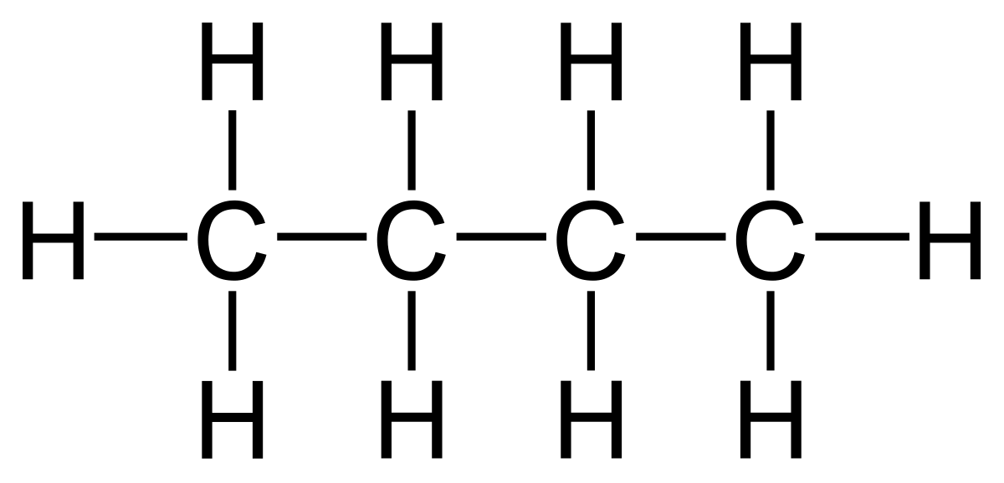

1. Butane belongs to what functional group?

**Alkane functional group**

1. Write down the chemical reaction.

**C4H10**

1. What is the balanced reaction?

**2C4H10 + 13O2 🡺 8CO2 + 10H2O**

1. How many moles of CO2 are produced when 0.845 moles of butane react with oxygen? Show work.

**0.2 moles of CO2 is produced**

1. How many moles of oxygen are required to burn 2.54 moles of butane?

**16.51 moles of oxygen are required**

1. **Calculate the molar mass of the following compounds (in g/mol) and show your work.**



**MW: 180.15 g/mol MW: 354.49 g/mol**

1. **How many moles of methane are found in 6.07 g of methane? Show your work**

**0.38 moles are in 6.07g of Methane**

1. **Which type of reaction has the highest atom economy (2 pts)?**

**Combination reactions**

1. **This following is the chemical process for the production of TiO2. What is the atom economy of this reaction?**

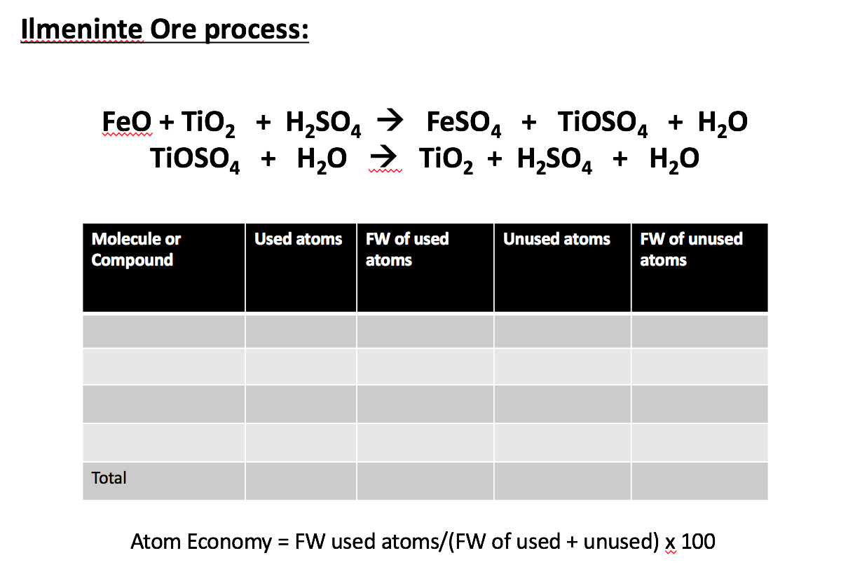

1. **What is the best E-factor possible (2 pts)? Is this tangibly possible?**

**A value of zero is the best E-factor possible. In some chemical reactions is it possible. However, for majority of the reactions**