Lesson Plan: Lecture 1

Course Introduction & Accidents and their Unintentional Consequences

Description
In this lecture students will learn about the course requirements and the innovative capabilities of Green Chemistry which will be covered during next 14 weeks. Students will also learn that accidents can be reduced or prevented with a thoughtful design using Green Chemistry principles.

Prior to Lecture
Optional/Supplemental Readings:
- Bhopal Plant Disaster – Situation Summary (optional)

Videos
- Accidents
- Modern Disasters
- Accidents: Why we should care
- Green Chemistry Approach to Accidents

Topics to Cover in Lecture
- Introduction to class
- Student introductions
- Ice breaker
- Syllabus and expectations for the class
- Chemical Plant Accidents
- Toxic Products

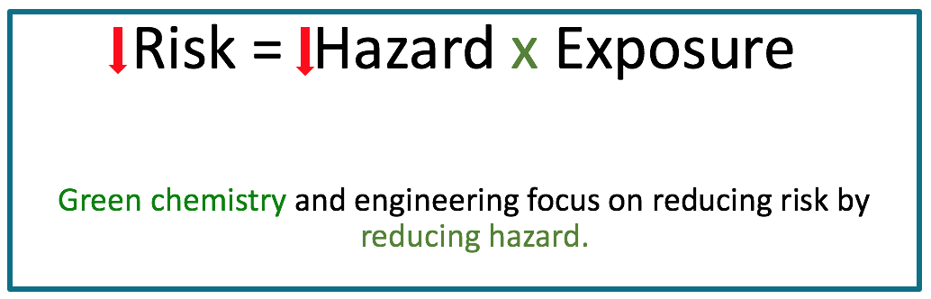

Class Exercise

The class opens with a simple exercise to open a discussion with students about what is and is not a chemical. Students are asked to identify products and materials in the classroom that are chemicals (and which they believe are not chemicals). This opens up the discussion about what constitutes a chemical and how all materials and products are made from chemicals. The instructor can discuss with the student that the term “chemical” is not a bad term – some chemicals can be harmful to humans and the environment and others are not (or are less harmful). This course will help students to understand more about the role of chemistry in sustainability and how essential chemistry is in creating more sustainable solutions to local and global challenges.

