ADME Exercise

ADME stands for Absorption, Distribution, Metabolism, and Excretion. ADME is a term used frequently in pharmacology and drug design, but that also has significant applications in both toxicology and green chemistry design. ADME “describes” the effectiveness of the drug by characterizing its toxicokinetics (uptake and fate of a chemical in the body). So before developing any chemical or drug, chemists should consider several metrics:
- The rate of uptake of the molecule
- How fast and where it is distributed
- How fast is it metabolized
- How fast can it be excreted from the body
In the realm of pharmacology, knowing these rates helps medicinal chemists design drugs which are not only the most effective, but more importantly, that target specific tissues. One of the classic examples of how understanding ADME led to an improved chemical design are allergy drugs. Allergy relief drugs, ‘aka’ antihistamines, are widely prescribed for seasonal and perennial allergies. The drug enters the brain, where it prevents histamines from binding to cells and blocks the allergy reaction mechanism. However, the first-generation antihistamine drugs were found to have a side effect. Because of their structure, antihistamines were very likely to accumulate in the brain and affect other receptors, which in turn lead to drowsiness. Understanding ADME allowed scientists to redesign the drug, which now enters the brain, reacts with the appropriate receptors on the cells, and is excreted before it affects other receptors.
Chemists and molecular designers have also used ADME to create guidelines for designing safer industrial chemicals. In this case, chemicals are designed such that they have a minimal effect on humans and environment. Ideally, chemicals shouldn’t bioabsorb (enter the body) in the first place. However, if they do, molecular designers want to reduce distribution, reduce bioactivation, and accelerate excretion. Many of the guidelines for chemists are derived from existing physicochemical properties and toxicity data.
In this exercise, participants will predict the most probable route of exposure for a chemical, given its physico-chemical profile.
Go to chemspider.com and put in the following CAS number (a unique number which is assigned to each chemical):
71-43-2 [Benzene]
Using physico-chemical parameters and their preferable and non-preferable ranges, fill out the following tables to predict respiratory, dermal and digestive absorption of compounds.
- Write down the numbers from chemspider in the appropriate box.
- Use the chart below to decide whether the property falls in the preferred (green) or not preferred (red) range.
- Discuss what is the likely route for benzene exposure.
DERMAL ABSORBTION
Parameter | Preferred | Not Preferred
Physical state | solid | liquid
LogP | Less than 0 or greater than | Between 0 and 5
Molecular weight | More than 400 Da | Less than 400 Da

RESPIRATORY ABSORBTION
Parameter | Preferred | Not Preferred
Particle size [nm] | More than 5 | Less than 5
Log P | Less than 0 or greater than 5 | Between 0 and 5
Molecular weight [Da] | More than 400 | Less than 400
Vapor pressure [mmHg] | Less than 0.001 | More than 0.001

DIGESTIVE ABSRORBTION
Parameter | Preferred | Not Preferred
Particle size [nm] | More than 100 | Less than 100
LogP | Less than 0 or greater than 5 | Between 0 and 5
Phase | solid | liquid
Molecular Weight [Da] | More than 500 | Less than 400

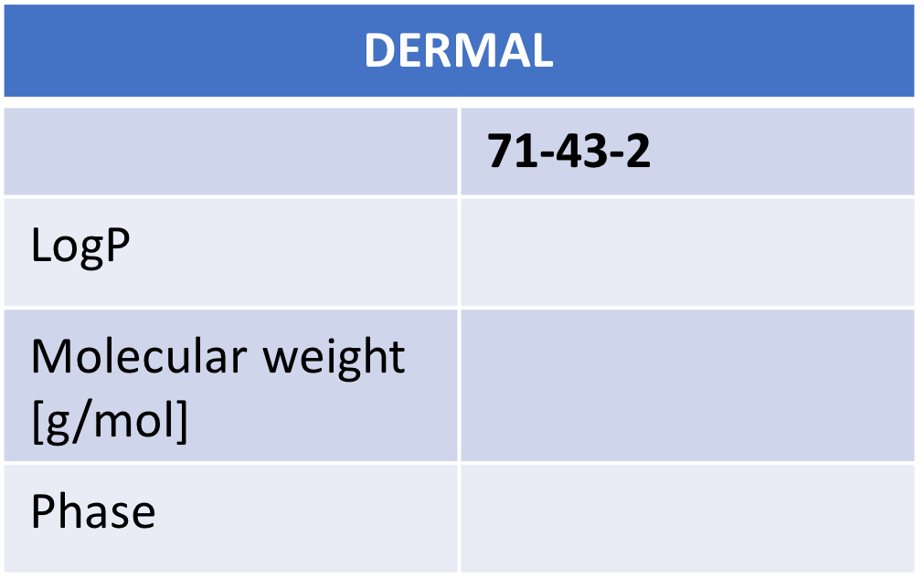
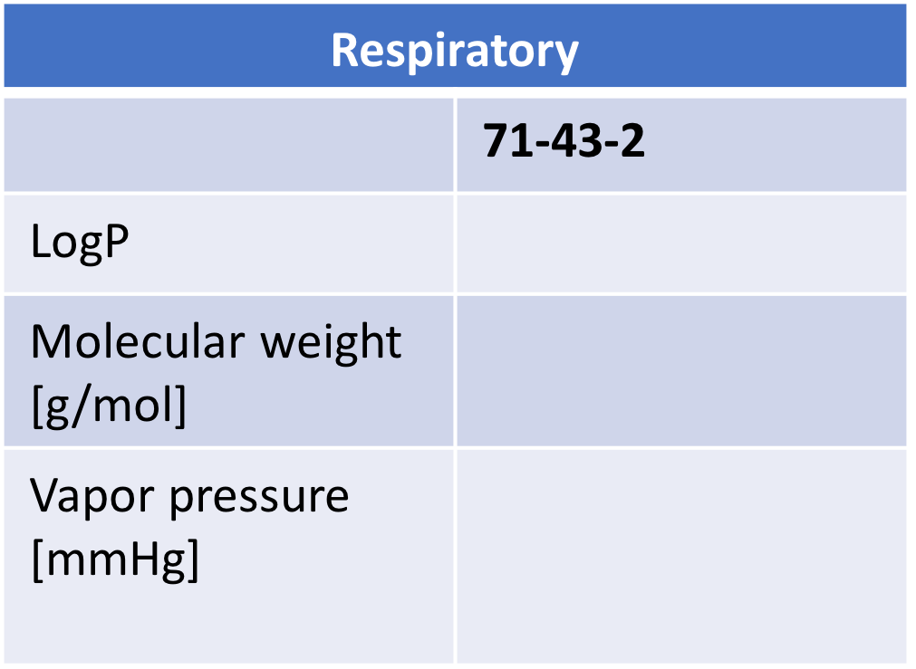

Digestive
71-43-2
LogP
Molecular weight
[g/mol]
Phase

DERMAL
 | 71-43-2--Benzene
LogP | 2.22
Molecular weight [g/mol] | 78.112
Phase | liquid

Respiratory
 | 71-43-2--Benzene
LogP | 2.22
Molecular weight [g/mol] | 78.112
Vapor pressure [mmHg] | 100.9

Digestive
 | 71-43-2--Benzene
LogP | 2.22
Molecular weight [g/mol] | 78.112
Phase | liquid

Conclusions:
- Benzene is volatile - it will absorb through the respiratory system.
- Once benzene is in the body, it has a moderate lipid and water solubility, therefore some of it will absorb in digestive track.
- Since it is a liquid, it will absorb easier than solid.
- Skin absorption is also probable.

