Life cycle exercise using Input-Output (Embodied Energy & Operating Energy) Quick tool to estimate the energy resulting from production of a product.

One of the goals of the sustainability lecture is to give participants an understanding of how we can measure sustainability using scientific tools to make sure that triple bottom line is achieved. This activity creates a comparison of two products, assesses the materials and energy resources required, as well as the environmental emissions resulting from making these products. The tool easily evaluates a commodity or service and provides guidance on the relative impacts of different types of products, materials, services, or industries with respect to resource use and emissions throughout the supply chain.

For example, the effect of producing an automobile would include not only the impacts at the final assembly facility, but also the impact from mining metal ores, making electronic parts, forming windows, etc. that are needed for parts to build the car.

In this exercise, participants will explore embodied energy and emissions associated with the manufacturing of an automobile versus a bicycle.

- Go to online tool: http://www.eiolca.net
- Click “Use the Tool” in the upper left corner.
- Once the new page opens, it should look like this:

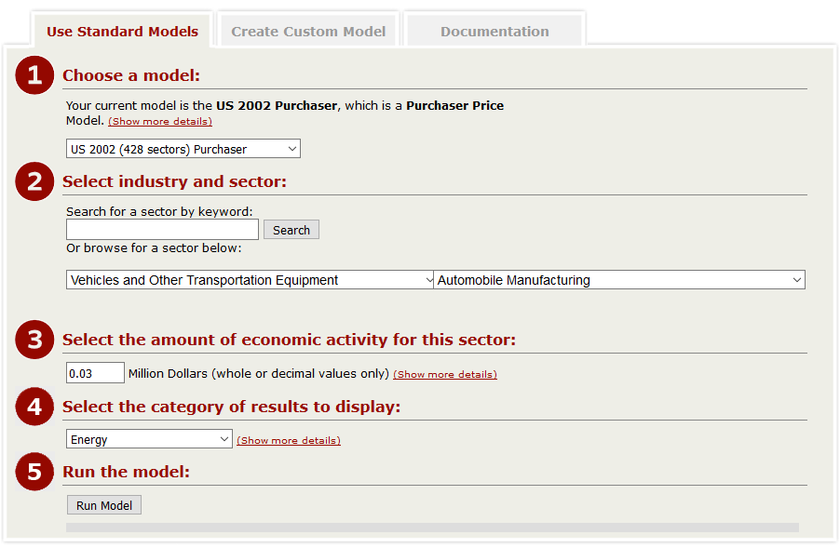
- There are several different models to choose from. For the purpose of this exercise, please select “US 2002 (428 sectors) Purchaser” model. This model will include all inputs up until the product is purchased, as opposed to production stage only. The “(Show more details)” link provides additional information on every database.
- Now, please select the “Vehicles and Other Transportation Equipment” sector and “Automobile Manufacturing” in detailed sector.
- Your car will be worth $30,000, which corresponds to 0.03 million dollars.
- And finally, please select “Energy” in the category of results to display and “Run” the model.

- The results are shown in the table. To produce the car worth $30,000 and to sell it to the purchaser, 0.218 of total energy (TJ) is used. This energy comes from coal (0.065TJ), Natural gas (0.063TJ), Petroleum (0.044TJ), Bio waste (0.010TJ) and Electric (0.036TJ).
- In column Sector, the total energy is broken down into sectors.
- Now, please “Change the Input” (upper left corner) to “Greenhouse gas”.
- Record the results.
- Please repeat the analysis for the bicycle.
- Please select the “Vehicles and Other Transportation Equipment” sector and “Motorcycle, bicycle and parts manufacturing” in detailed sector.
- Your bicycle is worth $200, which corresponds to $0.002 million dollars
- And finally, please select “Energy” in the category of results to display and “Run” the model.

- Compare and contrast the embodied energy and GHG emission for the car and bicycle.

Questions:
- How are the inputs similar, how are they different? (consider total energy and categories).
- Discuss the assumptions for the car and bicycle.
- Does the result change based on the product lifetime?

Yes - it depends how long do you use the car or a bicycle. If you buy a car every 5 years, the embodied energy will be higher per year than if you buy a car every 10 or 15 years.

Assuming that embodied energy for a car is 0.218 TJ over lifetime,
0.218/5 =0.436 TJ per year, providing that car is kept for 5 years = 121,111.11 kWH
0.218/10 = 0.0218 TJ per year providing that car is kept for 10 years = 6055.555555556 kWH
0.218/15 = 0.0145 TJ per year providing that car is kept for 15 years = 4,027.77 kWH

The average person in U.S. uses 10,766 kWh per year.

